Still quality education is the Dream for many children.
Education one of the fundamental right for every children, Irrespective of caste, race, socio-economic status its equal for each and every individuals, But still a lot of community which is waiting to access these fundamental right.
Salepali, a village of under Ullunda GP of that Block of Sonepur district, 40 tribal family had living there since 3 generation and depending upon the Brass forging handicraft of as a daily laborer in the brick industry for their livelihood. More than 40 children are there in that community and some children are enrolled in Government U.P. School Maraloe. And some are dropout because of various reason.
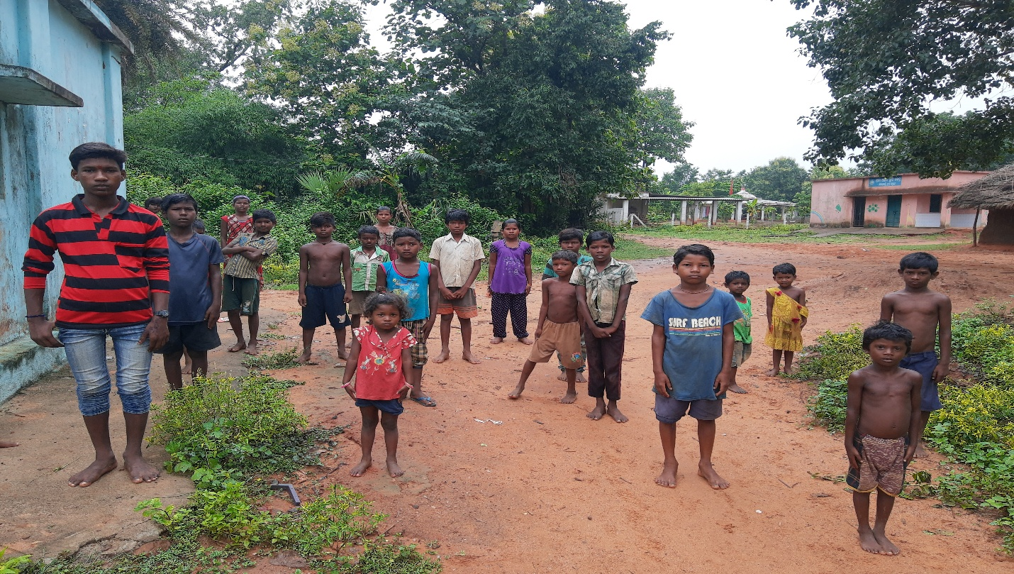
The children are very active and curious to learn, even they are very much interested to learn, but there are no scope for learning. The learning standard is not satisfactory, these children are the first generation learner and they really want to learn, still only one person in that community who is completed his 10th. So there are no ideal for them who can guide, teach and motivate them to continue their study. The parents are illiterate and they are always busy with their work. So nobody care for these children.
Since 2018 December GRAMOTHHAN start intervene with this community through the learning center concept and the trying to engage with the children, where initially start with 10 children and now we are working with 37 children, in this center GRAMOTHHAN try to able to learn the children in provided a learning environment and also trying to aware the parents as well as minimize the dropout rate. And able to re-enrolled 7 children successfully in the mainstream education.
The center runs in the community provided space which is the “Tendupatta” warehouse under forest department and now a days these place was used by the department so these children are unable to get a space where they able to assemble and continue their education.

